**SKS and SKKS Splitting Beneath Alaska: Evidence for Anisotropy in the Lower Mantle**

Eric Fein

Advisor: Dr. Maureen Long

Second Reader: Dr. Jeffrey Park

4 May, 2016

A Senior Thesis presented to the faculty of the Department of Geology and Geophysics, Yale University, in partial fulfillment of the Bachelor's Degree.

In presenting this thesis in partial fulfillment of the Bachelor’s Degree from the Department of Geology and Geophysics, Yale University, I agree that the department may make copies or post it on the departmental website so that others may better understand the undergraduate research of the department. I further agree that extensive copying of this thesis is allowable only for scholarly purposes. It is understood, however, that any copying or publication of this thesis for commercial purposes or financial gain is not allowed without my written consent.

Eric Edgar Fein, 4 May, 2016

Abstract

The core-mantle boundary is one of the most important, yet least understood, regions within Earth. Understanding the geodynamics of this region, which extends several hundred kilometers from the core into the mantle, is critical to developing a coherent theory of global geodynamics. In this study, we attempted to better constrain predictions of anisotropic mineral alignments in the lower mantle using discrepancies in SKS-SKKS splitting measurements. Anisotropy in the lower mantle arises due to uniform alignments of minerals caused by convection at the base of the mantle. Characterizing and mapping the location of regions with anisotropic minerals, which have unique deformation properties caused by mantle flow, furthers our understanding of mantle flow patterns. Our data analysis provides significant evidence for anisotropy along the southern coast of Alaska and along Canada’s west coast. No previous work had found evidence for anisotropy in that region. We also found little or no evidence of anisotropy in regions that previous work had shown to have uniform anisotropic contributions. The apparent discrepancy between the results from this study and those from previous work is likely explained by the angle at which the mantle was sampled by the seismic waves in question. Our approach examines seismic waves passing through the lower mantle nearly vertically, whereas previous work used horizontal sampling techniques. Our study shows that there is likely not a uniform anisotropic layer in the lower mantle beneath Alaska. Instead, there may be a more complicated arrangement or scattering of anisotropic minerals in this region. The lower mantle beneath Alaska should not be considered a simple shear zone; it is more likely a region with complex deformation geometries contributing to mantle dynamics.

Introduction

The core-mantle boundary is one of the most important but least understood regions within Earth. The processes and characteristics of lower mantle dynamics must be understood in order to understand controls on plate tectonics and the evolution of the planet. Constraining and understanding lower mantle dynamics is a critical step towards developing a coherent theory of geodynamics. Convection throughout the mantle, heat loss from the core, Earth’s thermal structure and Earth’s thermal evolution are all factors that must be understood in order to predict geodynamics in the lower mantle. Seismic analysis can be used to effectively image Earth’s internal structure and improve our understanding of that region. Seismic research exploring the lower mantle has illustrated the complexity of that region of Earth.

It is necessary to study the lowest several hundred kilometers of Earth’s mantle because the processes that take place in that region play a critical role in the evolution of the planet. This study focuses on a region of the lower mantle called D”. D” is a region at the base of the mantle whose thickness varies between 150-300 km in different locations on Earth (Garnero and McNamara 2008). This region of the mantle is characterized by unusually low seismic wave velocities and large seismic wave velocity variability (Grand et al. 1997). Although research has been able to clearly show that seismic velocities vary significantly within D”, the cause of the heterogeneity is not well understood. Research has suggested that compositional anomalies such as iron oxides formed by chemical reactions between perovskite and iron could create significantly denser minerals and hence seismically distinct regions (Jeanloz 1990). Thermal variations caused by subducting slabs that are relatively cool within D” could also produce heterogeneity. Seismic waves travel through cooler regions more quickly than through warmer regions and therefore subduction could also produce heterogeneity (Lay 1994). Anisotropic (directionally dependent) contributions to seismic wave propagation could also be responsible for the heterogeneity found in this region.

Anisotropy in the lower mantle is likely due to uniform alignments of minerals caused by convection at the base of the mantle. When certain minerals or mineral phases are uniformly aligned, seismic waves can travel at markedly different speeds depending on the direction of the wave relative to the alignment of the minerals (Garnero 2007 et al.). High-pressure phases that exist at the base of the mantle have the potential to be highly anisotropic. The flow at the base of a convecting system should be horizontal and as a result, minerals would be expected to have a preferential horizontal alignment (Matzel et al. 1996). If anisotropy is found, then horizontal flow is likely occurring and there may be a shear zone at the base of the mantle. By testing for the presence of an anisotropic contribution to seismic wave velocity within the D’’ layer, this hypothesis can be tested and our understanding of lower mantle dynamics can be improved.

In this study, we chose to examine the D" layer beneath Alaska for several reasons. Very little seismic anisotropy research has been conducted on this region. Alaska sits on the northern edge of the ring of fire and the Aleutian-Alaska subduction zone exhibits a high level of seismicity (Kissling and Lahr 1991). As a result, numerous seismic stations have been installed throughout Alaska, providing ample number of potential datasets for analysis. However, in the last two decades, there has been only one other study that has tested for anisotropy beneath Alaska. That study used seismic monitoring stations in the contiguous United States to test for anisotropy using horizontal and vertical components of shear waves with appreciable path lengths in the lower mantle beneath Alaska (Matzel et al. 1996). The present study is the first to use Alaska’s extensive seismic network to examine the lower mantle. This network of seismic monitoring stations has created a data set that can be used to study the lower mantle beneath the Aleutian-Alaskan subduction zone, and because of the position of the seismic network, the resulting dataset should for the first time test for vertical anisotropy in the test region.

There are multiple possible methods for analyzing a dataset of seismograms that can contribute to our understanding of lower mantle dynamics. Seismic wave velocity heterogeneity can be mapped using tomographic inversions of seismic data (Kissling and Lahr 1991). Anomalies in seismic velocity or velocity discontinuities at different depths within the lower mantle can be used to infer mantle compositional changes and specific mineral compositions (Meade et al. 1995). Additionally, differences in arrival times for the horizontal and vertical components of shear waves that travel through the lower mantle can be used to identify seismic anisotropy (Niu & Perez 2004). This study tests for seismic anisotropy in order to determine constraints on mantle flow patterns of the lower-most mantle.

Seismic anisotropy is important to characterize and map because when aggregates of anisotropic minerals develop, they exhibit unique deformation properties that are associated with mantle flow (Ando 1984). As a result, in order to understand the geodynamics of the lower mantle, it is useful to identify regions that exhibit seismic anisotropy. However, there are several possible contributions between the lower mantle and the surface that could artificially create an aggregate anisotropic signal. Simply using ray paths, such as SKS, that pass through the entire mantle presents several problems for measuring seismic anisotropy in the lower mantle as there is likely to be significant anisotropy in the upper mantle, particularly in the complex subduction zone beneath Alaska (Christensen and Abers 2010; Hanna and Long 2012; Jadanec and Biller 2010). It is important to understand these complicating factors to an anisotropic signal in order to avoid them and to isolate seismic signals that constrain anisotropies specifically in the lower mantle. All of these problems can be avoided by examining pairs of shear waves that traverse highly similar paths.

Both compressional and shear waves vary along different orientations of the crystal lattice in regions were seismic anisotropy is present. Shear wave splitting can be used to effectively and unambiguously identify anisotropy (Wysession 1994). As energy waves travel through Earth, they undergo a P-to-S conversion at the core-mantle boundary. This means that any observed anisotropy can be confined within the mantle to the slab on the receiver-side path rather than on the event-side path (Meade et al. 1995; Niu and Perez 2004). If there is no anisotropy, then as the shear wave undergoes the P-to-S conversion, all components are radially polarized and there is no detectable energy on the transverse component (Lay and Young 1991). However, if there is anisotropy between the core-mantle-boundary and the receiver, then SKS and SKKS waves undergo splitting and energy on the transverse component is measurable (Meade et al. 1995). SKS and SKKS waves have similar ray paths in the upper mantle but different ray paths in the lower mantle (Figure 3). Additionally, because they have the same back azimuth, the effect of multiple anisotropic layers does not need to be considered. This means that any differences observed in the splitting between the SKS and SKKS waves is indicative of the presence of seismic anisotropy in the lower mantle (Long et al. 2009).

Anisotropy has a three dimensional orientation which means that shear-wave splitting depends on azimuth, or the angle that seismic waves approach and enter a specific region (Merkel et al. 2007). Therefore, it would be valuable to establish a link between observations and dynamical predictions because it could make it possible to constrain mantle flow patterns and the rheology of specific regions of the lowermost mantle (Garnero et al. 2004). The most ubiquitous minerals in the lower mantle, perovskite (Pv), post perovskite (pPv) and magnesiowustite, are all strongly anisotropic but have been shown to respond in unconstrained patterns to deformation which makes it difficult to draw conclusions about lower mantle flow patterns from observed anisotropy (Lay and Ganero 2007). Magnesiowustite and pPv have different rheologies meaning that the weaker of the two minerals can accommodate much more deformation, and as a result exhibits more lattice-preferred orientation, than the stronger mineral (Lay and Ganero 2007). Additionally, it is important to determine if pPv is the cause of the D” discontinuity because if it is the dominant mineral associated with D” anisotropy then there may be an offset between the depths of the discontinuity and the onset of anisotropy (Ganero et. al 2008). There must be an offset because some finite amount of deformation is required to develop lattice-preferred orientations in pPv (Garnero et al. 2008). This has important implications for mapping and understanding seismic measurements.

Only one other study has examined anisotropy in the lower mantle beneath Alaska. Matzel et al. (1996) simultaneously modeled SH and SV seismic phases that interact with the D” layer. By fitting their data to models that assume anisotropy, Matzel et al. were able to account for the observed seismic wave behaviors and to infer the presence of anisotropy in the lower mantle. Since the publication of their work, researchers have developed additional methods for determining anisotropy. In this study, we examine both SKS and SKKS seismic phases that interact with the D” layer and were recorded by seismic stations in Alaska. By analyzing these two seismic phases for discrepancies in their energy signatures, we were able to determine if a significant anisotropic contribution affected their paths through the lower mantle. Then, by plotting the location of a discrepant pairs, we were able to determine regions that exhibit evidence of anisotropy.

Data and Methods

The Alaska network is a permanent broadband regional network maintained by the Alaska Earthquake Information Center based in Fairbanks, Alaska. The network extends from the Aleutian Islands into mainland Alaska. The majority of stations used to gather seismic data for this study are clustered in the central Denali region of mainland Alaska; however, several additional stations from the surrounding islands were also included in this study (Figure 1). The Alaskan network of seismic stations was established in 1998 as part of a broader national effort to expand understanding of the seismic landscape (Eberhart-Phillips et al. 2006). For this study, all active stations with continuous seismic records of greater than 6 months were included in our initial data gathering efforts. Seismic records from a total of 36 stations were used to create splitting measurements of seismic data. Figure 1 shows a map of all stations included in this research.

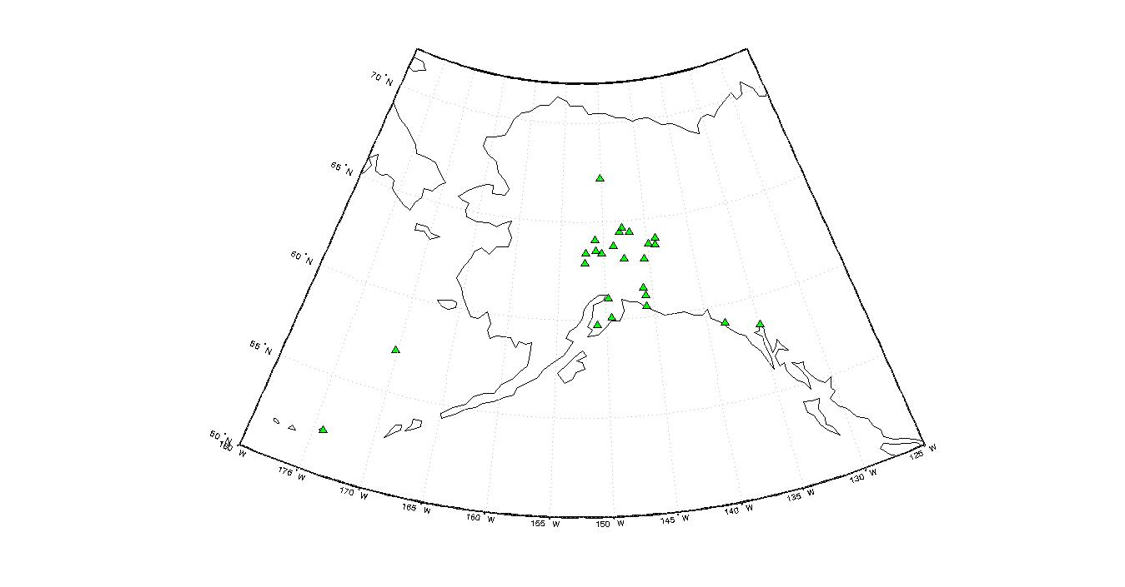

*Figure 1: Display of the distribution of seismic stations included in this study. Green triangles indicate the locations of individual seismic stations.*

At each station, the seismic record was pulled for specific time intervals corresponding to the record of earthquakes with magnitudes greater than 5, and with epicentral distances between 108 and 120 degrees from the station. We examined just over 3000 unique station-earthquake SKS-SKKS pairs in order to produce 49 well-constrained pairs of splitting measurements (both null and non-null) from 31 individual earthquakes. Each station had logged approximately 100 events that met the necessary criteria, indicating that seismic waves from the events both passed through the desired region of the lower mantle and were substantial enough to produce distinguishable energy arrivals. However, the majority of events did not produce a splitting measurement that could be used due to unconstrained error or too much noise; fewer than 2% of the possible candidate events could be used. As a whole, the network has relatively broad back-azimuthal coverage (Figure 2). This allows us to survey a broader area of the lower mantle, which in turn allows us to create more robust inferences about anisotropic structure in D” (Figure 3).

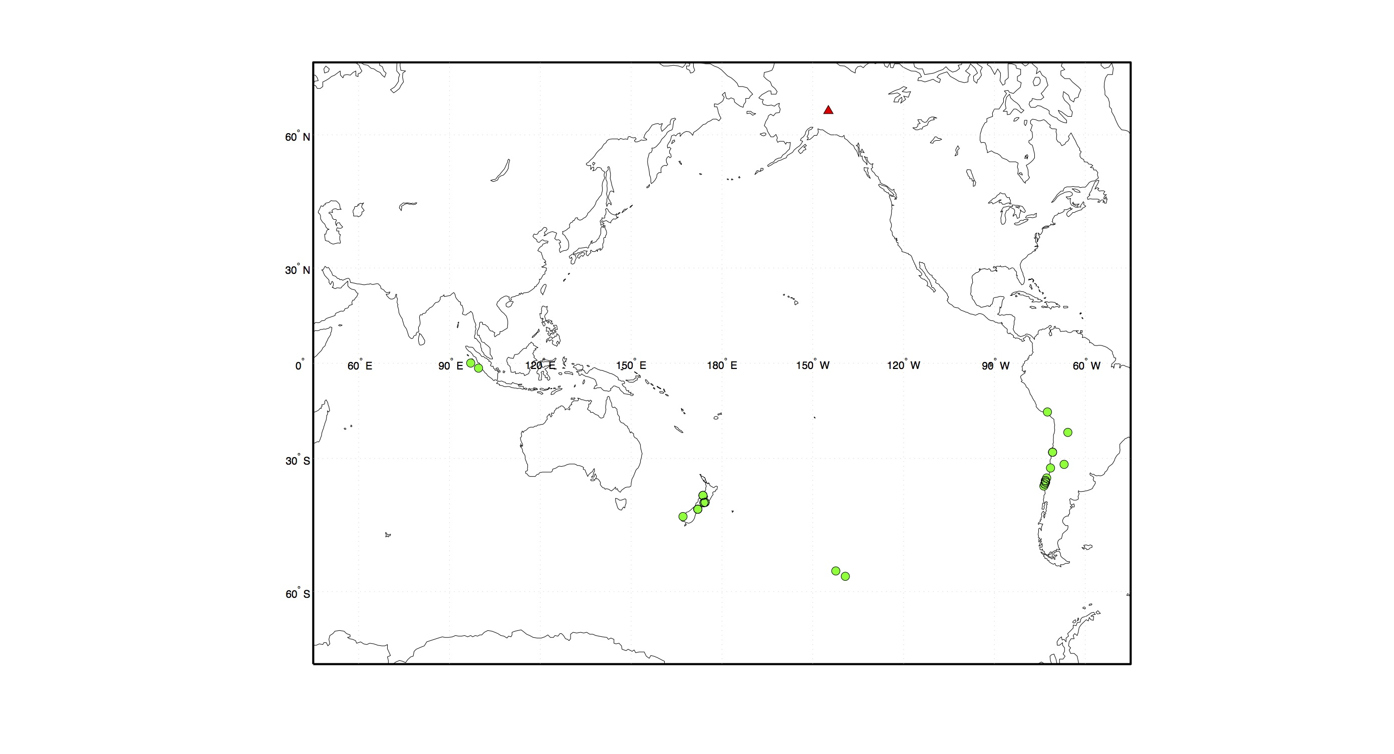

*Figure 2: Distribution of seismic events that produced well-constrained splitting measurements that could be used for this study. The green dots represent the locations of seismic events. The red triangle represents the location of one seismic monitoring station included in this study.*

The locations of the seismic events used in this study were selected so that they would be able to determine anisotropy in the vertical direction beneath Alaska.

Figure 3 illustrates the ray paths that SKS and SKKS waves take as they travel through Earth, pass through the lower mantle and arrive at a seismic monitoring station on the other side of the planet. This figure provides a visual representation of the angle that SKS and SKKS waves measured in this study passed through the lower mantle. This figure also illustrates that there are two SKKS wave paths. It is important to be cognizant of that fact during data analysis in order to select the correct arrival signature for analysis. In this study, we were only concerned with the first arrival (red line, shorter path) because that trajectory can be compared with the SKS wave in order to determine anisotropy.



*Figure 3: Map of SKS and SKKS wave paths through a cross-section of Earth. The triangle indicates the location of the seismic monitoring station and the asterisk indicates the relative location of the seismic event. This particular model, produced using SplitLab, demonstrates the path of a seismic wave that was created by an event occurring between 108 and 120 degrees away from a recording station in Alaska.*

In order to produce well-constrained splitting measurements, there were several stages of data pre-processing that were completed using the SplitLab software package (Wustefeld et al., 2008). By calculating the distance travelled and the corresponding time, we precisely determined when the energy arrivals for the SKS and SKKS waves should appear in a specific seismic record. A seismic record, even for a single event, is complex and must be carefully constrained in order to isolate the desired energy arrivals (Figures 4 & 5). Second, we applied a bandpass filter to each waveform with a corner frequencies range of 0.01-0.08 Hz. In some cases, we adjusted the frequency on either end of this range to optimize our measurements. The specific frequency was chosen manually depending on signal and noise properties of each earthquake-station pair in order to filter out as much extraneous noise as possible. The bandpass filter serves to optimize waveform clarity and can remove a significant amount of residual noise in a seismic measurement. Additionally, all waveforms and splitting measurements were visually inspected to ensure that each SKS or SKKS arrival was not contaminated by other phases or by too much ambient noise. The majority of measurements were contaminated, which is evident in the remarkably high attrition rate of the data.



*Figure 4: Graph of the travel time and distance travelled by the SKS and SKKS waves as they pass through Earth. The dotted line within the green section corresponds to the correct distance for a specific station. The intersection of the dotted line and the SKS and SKKS lines provides the expected time window for each phase arrival.*

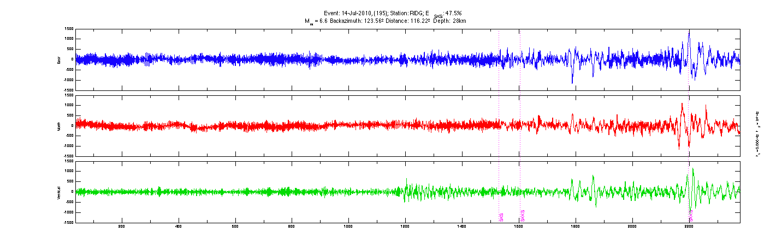

*Figure 5: An example unfiltered, uncorrected seismogram. The blue, green and red lines represent vertical, northern and eastern motion relative to the orientation of the seismic station. The pink dotted lines represent the calculated expected arrival times for the SKS and SKKS waves.*

During splitting analysis, we determined if each measurement was well constrained or if there was too high a degree of error to include an individual measurement. After isolating the correct energy arrivals, we used Splitlab to produce data sheets illustrating more detailed information from each waveform (Figure 6 and 7). We assigned each splitting measurement a quality of “good”, “fair” or “poor” using several parameters. First, the chart found in the top left corner of both Figure 6a (SKS) and Figure 6b (SKKS), as well as the “corrected fast & slow” and “corrected Q” charts, illustrate that there is a clear energy arrival at the expected time for each phase. This is important to check because if there is no clear arrival then the rest of the measurements are likely inaccurate and should not be included. Finally, the two charts in the furthest column to the right titled “Energy Map of T” and “Map of Correlation Coefficient” provide information about the error in each measurement. The chart “Energy Map of T” shows how much energy is on the transverse component after it has been corrected for splitting. A larger dark gray region means that relatively more energy was left on the transverse component and means the measurement is not well-constrained. In the chart “Map of the Correlation Coefficient”, the regions shaded dark gray represent uncertainty in the wave measurement. If the regions from either of these plots are too large, then we consider that to be evidence of too much error in the measurements and we discard that event from further consideration. In Figures 6a and 6b, the regions shaded dark gray are well-constrained, small and do not overlap. As a result, there is an acceptably low level of error, and we use these data in our analysis. This processing step removed the vast majority of SKS-SKKS pairs from consideration in the usable data set.

In order to determine the location of anisotropy in the lower mantle, the usable SKS and SKKS pairs must be characterized as “discrepant” or “non-discrepant”. Discrepant pairs are evidence of anisotropy. There are several steps involved in characterizing a pair of SKS and SKKS waves as discrepant or non-discrepant. First, the uncorrected particle motion is examined in order to determine if the particle moves in a linear pattern (Figure 6: Particle Motion Before and After). If particle motion is linear, that waveform is characterized as “null”. However, if particle motion is elliptical, that waveform is characterized as “not null”. This characterization indicates either isotropy or alignment of the back-azimuth with the fast or slow axis of an anisotropic medium. If both the SKS and SKKS arrivals are both characterized as “null” or both characterized as “not null”, then the pair is considered non-discrepant indicating no evidence for anisotropy. However, if the characterization of the SKS and SKKS arrivals does not match, then the pair is considered discrepant, indicating anisotropy in the lower mantle at the points measured.

In Figure 6, for the SKS-SKKS pair shown, the difference between elliptical and linear particle motion is clearly illustrated in their respective charts labeled “Particle Motion Before and After”. In Figure 6a, particle motion follows a nearly linear path. However, in Figure 6b, it is clear that the path motion is not linear. As a result, it is possible to label the first data sheet as “null” and the second data sheet as “not null”. Since the characterizations do not match, the SKS-SKKS pair is considered discrepant and therefore the pair indicates evidence of anisotropy.

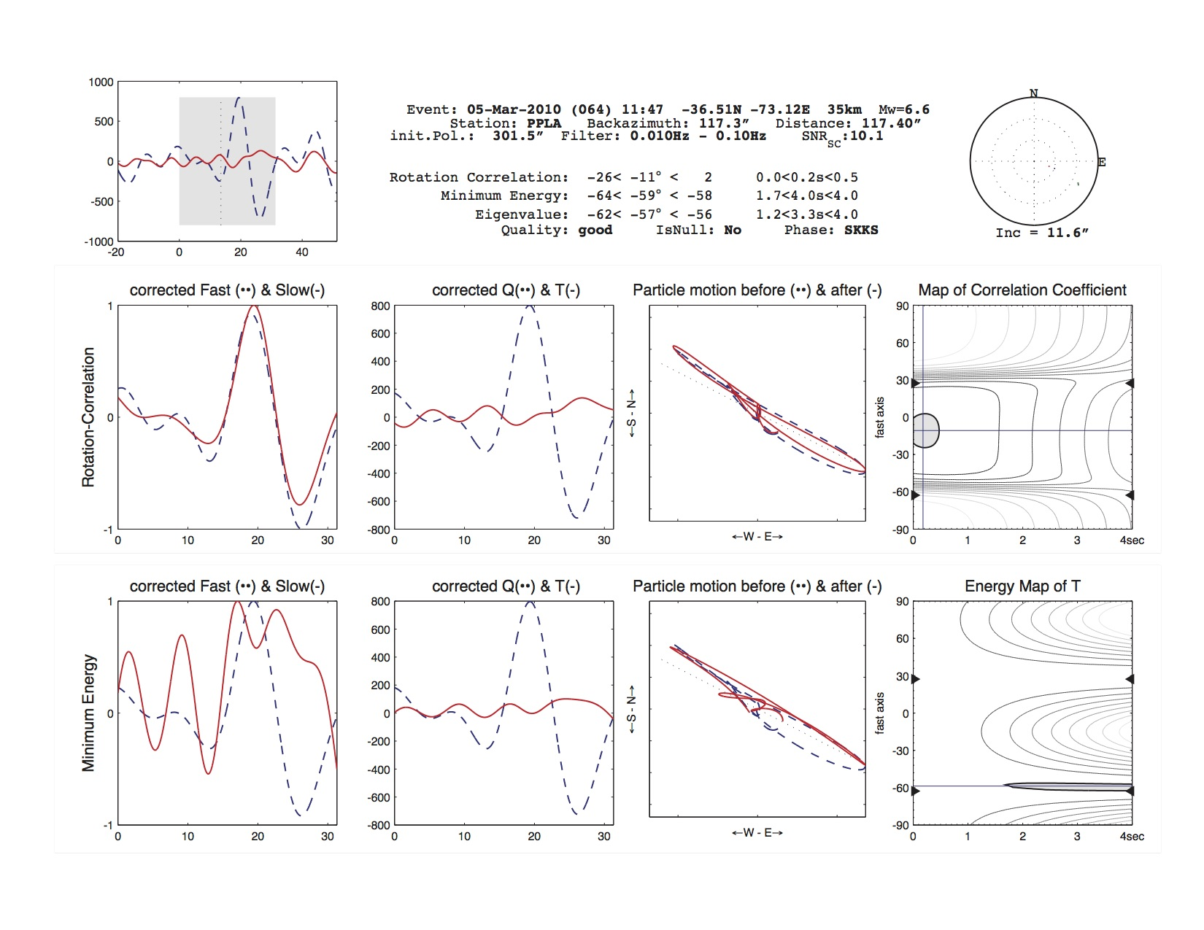

Macintosh HD:Users:ericfein:Downloads:PPLA Combined.pdf

*Figure 6. Example data sheets for a discrepant SKS-SKKS pair. This pair was produced from a measurement of a magnitude 6.6 earthquake recorded at seismic station PPLA in Alaska on March 5, 2010. Figure 6a (top sheet) was created from the SKS arrival and Figure 6b (bottom sheet) was created from the SKKS arrival.*

Analysis of the data represented in Figure 7 produces a significantly different result than analysis of the data represented in Figure 6. The charts representing particle motion in Figures 7a and 7b do not indicate any evidence of anisotropy. In both Figures 7a and 7b, the particle motions are similar, and although they are not perfectly elliptical, they are clearly not linear and both follow similar paths. Neither were characterized as “null” and as a result, this SKS-SKKS pair can be labeled “non-discrepant” meaning that there is no evidence for anisotropy.

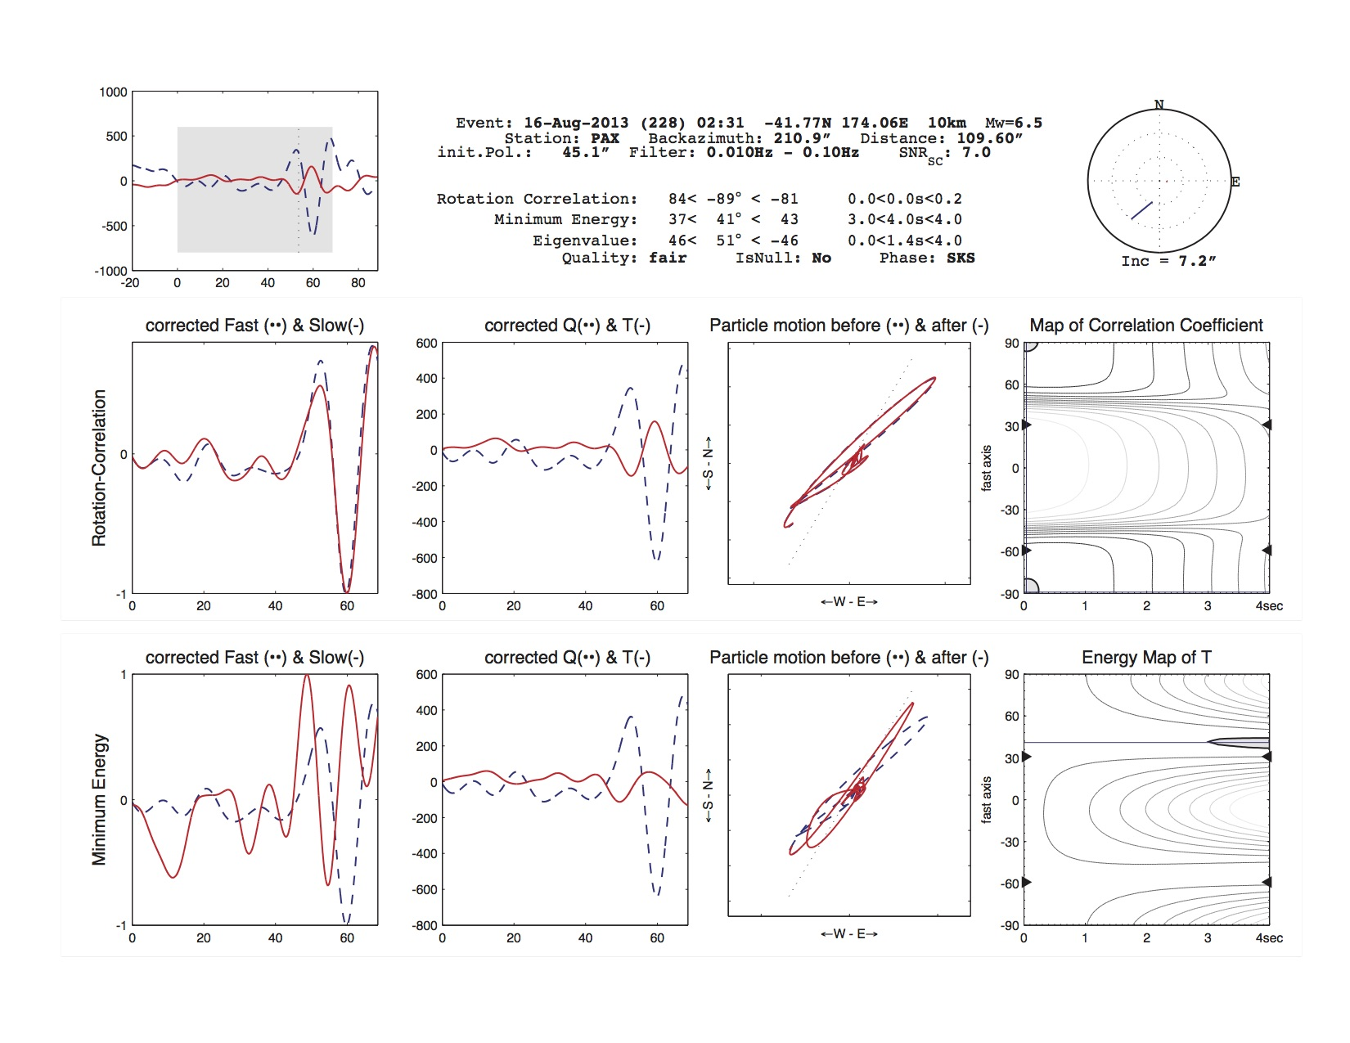

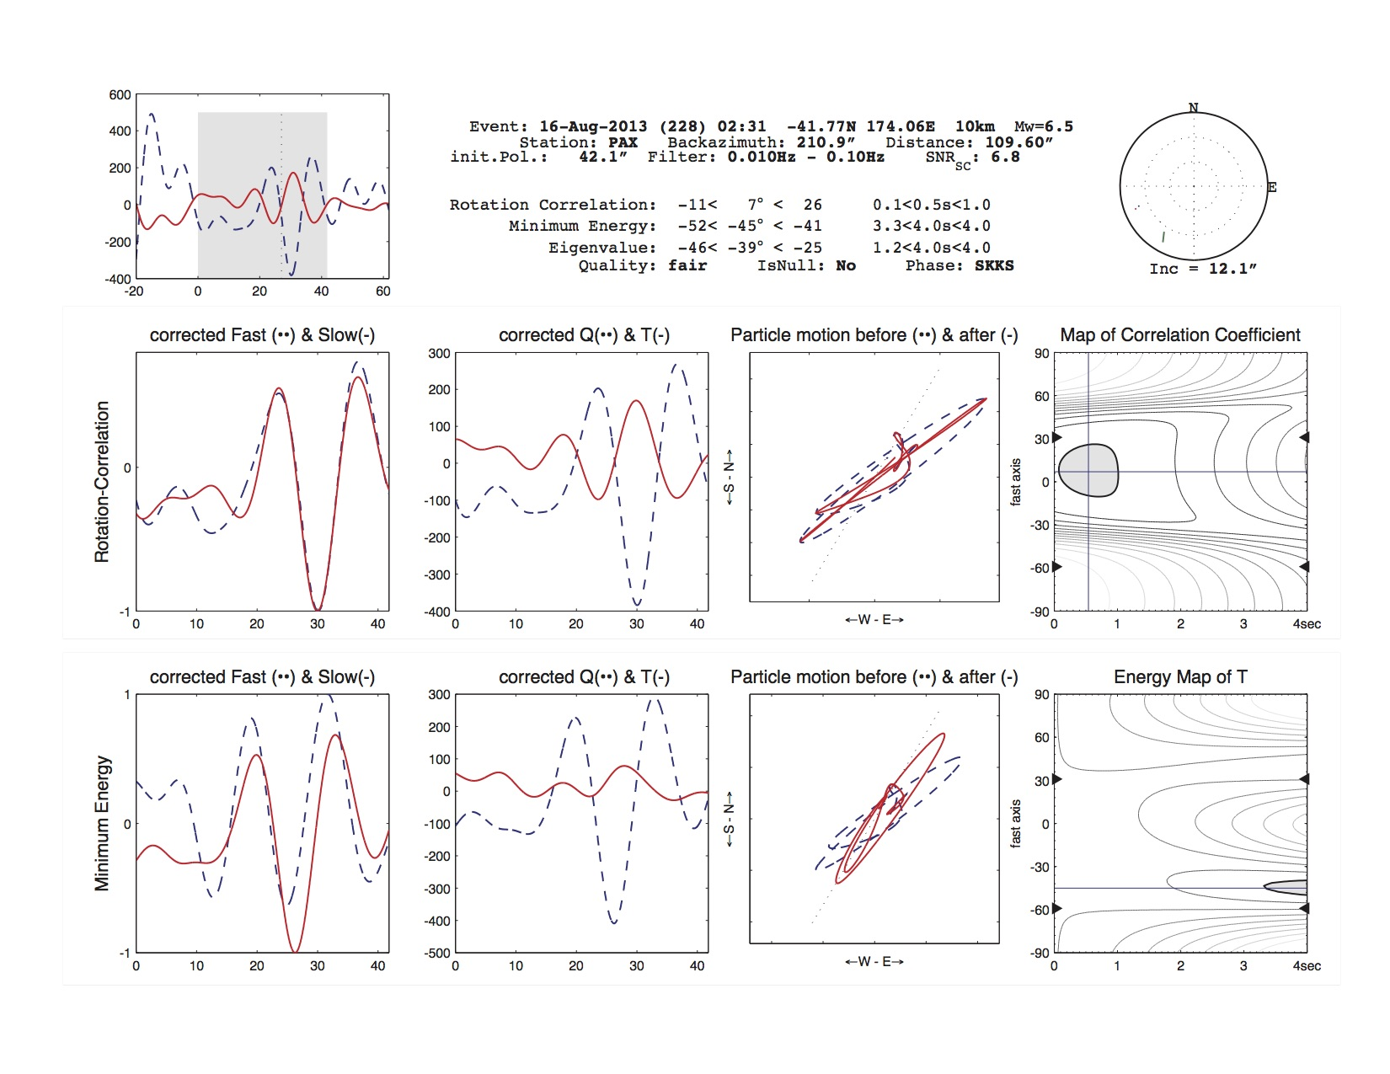

*Figure 7. Example data sheets for a non-discrepant SKS-SKKS pair. This pair was produced from a measurement of a magnitude 6.6 earthquake recorded at seismic station PAX in Alaska on August 16, 2013. Figure 7a (top) was created from the SKS arrival and Figure 7b (bottom) was created from the SKKS arrival.*

For each SKS-SKKS pair, we considered the measured splitting parameters in combination with the event location and station location. The event location and station location data points can be used to calculate the location where the SKS and SKKS waves pass through the lower mantle. It is critical to calculate these locations because that is how we determine which regions of the lower mantle exhibit anisotropy and which regions do not. The coordinates for mapping the SKS and SKKS phases were calculated using the TauP Toolkit (Crotwell et al. 1999), which is a seismic travel time calculator. However, in addition to travel times, the TauP Toolkit can also be used to calculate derivative information such as ray paths through Earth, pierce points and turning points. It not only can calculate variable velocity models, but it can also determine arrival times for the majority of measured seismic phases (Crotwell et al. 1999). In this study, we used the TauP Toolkit to calculate the pierce points of SKS and SKKS waves as they traveled through the lower mantle.

After calculating SKS and SKKS pierce points, the data were plotted on a map of Alaska and Northern Canada using the Mat Lab mapping software package in order to determine geographic patterns in the locations of discrepant and non-discrepant pairs. Discrepant and non-discrepant pairs were distinguished using distinct colors, and associated seismic stations were also plotted for reference.

Results

This study analyzed 3047 splitting measurements in order to find SKS-SKKS pairs that had usable data. In total, 49 SKS-SKKS pairs were obtained. Of those 49 measurements, 7 were discrepant and 42 were non-discrepant. Figure 8 is the map of all 49 events, illustrating the location of all discrepant and non-discrepant pairs. Discrepant pairs indicate evidence of anisotropy and non-discrepant pairs indicate no evidence of anisotropy.

Figure 8 illustrates a spatially varied distribution of discrepant pairs. There is a cluster of 4 discrepant pairs along the southeastern shore of Alaska. Although non-discrepant pairs surround this cluster of 4 discrepant pairs, the fact that they are all in one geographic location is likely not a coincidence. Instead, this cluster represents evidence of a potential anisotropic contribution from the region of lower mantle directly beneath this part of Alaska. There are three other discrepant SKS-SKKS pairs that could also suggest possible anisotropic contributions from the lower mantle. The first is directly south of mainland Alaska. This discrepant SKS-SKKS pair is completely surrounded by a multitude of non-discrepant pairs. The fact that none of these surrounding SKS-SKKS pairs exhibit any evidence of anisotropy suggests that the lone discrepant SKS-SKKS pair is an anomaly and should not be considered indicative of that region. The two other discrepant SKS-SKKS pairs are located further to the north, off of the western coast of Alaska and each pair is isolated. While they could be indicative of anisotropic contributions, their isolation means that we cannot draw any firm conclusions about those regions from these solitary data points.



*Figure 8: Map of SKS and SKKS pierce points indicating anisotropy in the lower mantle. The cyan triangles represent the location of each seismic monitoring station used in this study. The red dots represent the SKKS pierce points of discrepant ­­­SKS-SKKS pairs. The blue dots represent the SKS pierce points of discrepant ­­­SKS-SKKS pairs. The yellow dots represent the SKKS pierce points of non-discrepant ­­­SKS-SKKS pairs. The green dots represent the SKS pierce points of a non-discrepant ­­­SKS-SKKS pair.*

There are several possible ways to measure anisotropy in the lower mantle. By comparing the alternate techniques each method employs, and the results they produce, we can improve our understanding of lower mantle geometries and dynamics. Figure 9 depicts anisotropy as determined by a global tomography model that was produced using IRIS software and data. A global tomography model determines anisotropy using a fundamentally different method from the method used in this study. Just as there are different ways to vibrate a string, there are numerous modes in which Earth vibrates after earthquakes of a particular size. After a large earthquake, the Earth continues to vibrate, much like a bell after it has been rung. Global radial anisotropy models are able to use seismic measurements of travel times, body waves and normal mode data to determine the way the entire Earth vibrates during one of these large seismic events, and these models can be used to calculate the extent of anisotropy in the lower mantle. The key feature of Figure 9 is that the region directly south of mainland Alaska and along the Aleutian Islands exhibits anisotropy, and the region along the southern coast of Alaska stretching into the western coast of Canada exhibits little to no evidence of anisotropy in a global radial anisotropy model. These results are not consistent with the results produced in this paper. However, the global radial anisotropy model samples the lower mantle at a different angle than the SKS-SKKS sampling technique used in this study. This could explain the discrepancy, and suggests that different information about the lower mantle can be provided by each technique.

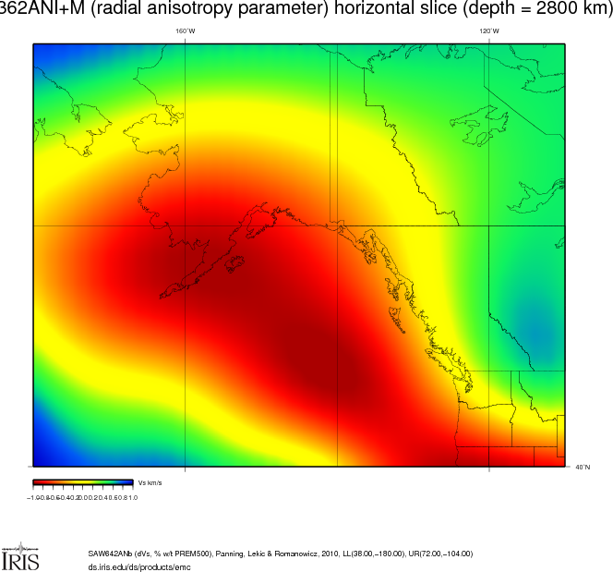

*Figure 9: Map of radial anisotropy in the Alaska study area as computed by a global tomography model. In this map, regions that are dark red exhibit the strongest signals of anisotropy and regions that are blue exhibit the weakest signals of anisotropy.*

In order to understand the meaning of the spatial distribution of discrepant and non-discrepant pierce points, it is helpful to consider other physical properties of the regions being examined. The temperature of a medium affects the velocity of seismic waves that pass through it. There are significant variations in temperature in the mantle below Alaska, and Figure 10 illustrates the effect that this temperature gradient has on seismic wave velocities in the region. The velocities along the coast of Alaska are significantly slower than in the region directly south of mainland Alaska. There is some variability in speeds within the region directly south of mainland Alaska. The region directly south of the Aleutian Islands exhibits slower seismic velocities than the region along Alaska’s southern coast.

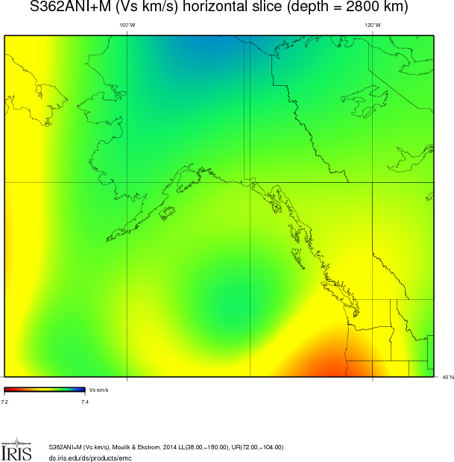

*Figure 10: Tomographic map of seismic wave velocities in the lower mantle beneath Alaska produced using IRIS software and data. Velocities on this map vary between 7.2 (red) and 7.4 (blue) km/s.*

Discussion

Evaluating Possible Anisotropic Regions

The results of this study did not suggest evidence for extensive anisotropy in the lower mantle below Alaska. The majority of SKS-SKKS pairs examined were not discrepant. This is a significantly different result from the findings presented by Matzel et al. (1996) who found that an anisotropic model of the lower mantle successfully fit their observed or collected data. They found evidence of anisotropy throughout the region below Alaska and along the Aleutian islands. The results of this study provide evidence that does not support the findings from Matzel et al. (1996). In the same region that Matzel found anisotropy, our results suggest that there is likely little or no anisotropy. Although there are three scattered pairs within the western region surveyed by this study, the discrepant pairs are not clustered together and are all surrounded by numerous non-discrepant pairs. That suggests that they may have come from small isolated anisotropic regions but that there is not an entire region below the western portion of Alaska that is strongly and uniformly anisotropic as Matzel et al. suggested.

Although we found little evidence for anisotropy in the region studied by Matzel et al. (1996), we did measure significant anisotropy outside of their study region. Our pierce points extend both east and south from the region examined by Matzel et al. We find the most significant evidence of anisotropy in the region directly to the southeast of the Alaska-Canada border. In that region, we discovered four discrepant SKS-SKKS pairs. All four pairs were clustered together, suggesting that there is an anisotropic contribution in that region of the lower mantle. The fact that these discrepant pairs are clustered together provides evidence that there is a real contribution from the lower mantle and that the effect is not simply a lone anomaly. However, there were also several non-discrepant pairs found in close proximity to the clustered discrepant pairs. The presence of non-discrepant pairs suggests that this region of the mantle has complexities that are too fine for the scale of the measurement techniques used in this study to resolve. However, there is clearly evidence of an anisotropic contribution and as a result, additional research focused specifically on this region could provide improved resolution.

The apparent discrepancy between the results found by Matzel et al. (1996) and the results presented in this study could be caused by the difference in sampling techniques employed by the two studies. Matzel et al. (1996) used data from seismic monitoring stations located in the contiguous United States. They were able to analyze the lower mantle beneath Alaska by selecting seismic events whose ray paths through the lower core beneath Alaska before resurfacing in the contiguous United States. This enabled them to test for anisotropy in a horizontal direction. In the present study, we used data from seismic monitoring stations located in Alaska. The ray paths of seismic waves that pass through the lower mantle and resurface in Alaska travel through the lower mantle at different angles than seismic waves that are measured by seismic monitoring stations in the continental United States. The technique used in this study allowed us to measure anisotropy in a nearly vertical direction. As a result, the discrepancy in anisotropic signatures is likely a result of sampling that region from different angles. It is possible that the geometry of minerals in the lower mantle could produce anisotropic signals when sampled horizontally, but not when it is sampled vertically.

Comparing the regions where we believe anisotropy is present to tomographic maps of the lower mantle provides additional useful insights. First, comparison of Figures 8 and 10 demonstrates that in the regions where we find evidence for anisotropy, seismic velocities are generally slower than in the eastern regions sampled in our analysis, suggesting that the same properties that cause slower seismic velocities could also contribute to anisotropy. Figure 9 illustrates regions beneath Alaska that should produce anisotropy using a radial anisotropy parameter, which like the Matzel et al. (1996) study is constructed through horizontal sampling of the lower mantle by seismic waves. Both Figure 9 and the results of Matzel et al. (1996) provide evidence for significant anisotropy off the coast of Alaska and Canada, directly south of Alaska. The results presented in our study suggest an alternative conclusion. We found the least evidence for anisotropy in the same region where Matzel et al. (1996) found the strongest evidence for anisotropy. This apparent contradiction could be a result of sampling the lower mantle from different directions. Again, it is possible that sampling different azimuths provides different anisotropy results because anisotropy is dependent upon angles of approach. The fact that different angles of sampling produce different results about anisotropy in a given region is not unreasonable, and could indicate directional differences in lower mantle dynamics.

The results from this study suggest a number of implications about lower mantle dynamics. The only other study of the lower mantle in this region suggested that there was a uniform field of anisotropy in the lower mantle beneath Alaska. However, our study provides evidence that this may not be the case. Instead, there might be a more complicated arrangement or scattering of anisotropic minerals in this region. This is important because it means that mantle flow in this region of the lower mantle should not simply be considered to be a simple shear zone. It is likely that there are complex deformation geometries contributing to mantle dynamics in the region of D”.

Summary

In this study, we examined an extensive dataset of seismic events measured by the Alaskan seismic network. By calculating the pierce points of the SKS and SKKS phases of each seismic event, we were able to constrain the location of regions of anisotropy in the lower mantle across a broad area surrounding the Alaskan Seismic Network. We found significant evidence of anisotropy along the southern shore of Alaska extending along the western coast of Alaska, and aside from several isolated pierce points, we found no significant evidence of anisotropy in any other regions. Our results did not support the conclusions presented by previous work on anisotropy beneath Alaska. Matzel et al. (1996) found extensive evidence for anisotropy in the region directly south of mainland Alaska and did not find any evidence to support an anisotropic contribution beneath the southern Alaska – Canada shore. We suggest that the discrepancy between our results and those of Matzel et al. (1996) is caused by differences in trajectory through the lower mantle of the seismic waves sampled in each study. In our study, we analyzed seismic waves that passed vertically through the lower mantle beneath Alaska. Matzel et al. (1996) analyzed seismic waves that passed horizontally through the lower mantle beneath Alaska. The different results from the two studies, therefore, are not necessarily inconsistent with each other, and may reflect real behaviors of the lower mantle in this region. Anisotropy is directionally dependent and therefore, the angle of approach could create variable anisotropic contributions. As a result, it is critical for studies that test the lower mantle for anisotropy to qualify that classification with the angle or angles that they used to sample the region.

These studies suggest that there is evidence of anisotropy in the lower mantle beneath Alaska. Anisotropy in this region appears to be spatially scattered and to vary strongly with the direction that the sampling seismic waves traverse through the region. Future work should examine SKS-SKKS pierce points that surround the isolated pierce points off the western coast of Alaska. This study found only four usable SKS-SKKS pairs that sampled the western coast of Alaska. However, two of the four pairs measured in that region demonstrate evidence for anisotropy. A more comprehensive study focused on that region could change and improve our understanding of the geometries beneath Alaska. Creating a more comprehensive map of anisotropy will allow us better understand the geodynamics of the lower mantle beneath Alaska.

Acknowledgements

Special thanks to Dr. Maureen Long for the hours she spent supporting me and making my research possible.

References Cited

-Ando, M., (1984). ScS polarization anisotropy around the Pacific Ocean. Journal of Physics of the Earth Issue 32, pp. 179–195.

-Brocher, T.M., Christensen, N.I., (1990). Seismic anisotropy due to preferred mineral orien- tation observed in shallow crustal rocks in southern Alaska. Geology Issue 18, pp. 737–740.

-Christiensen, D.H., Abers, G.A., (2010). Seismic anisotropy under central Alaska from SKS splitting observations. Journal of Geophysical Research Issue 115, pp. 431 445.

-Crotwell, P. (1999). WebWEED and TauP: Java and seismology.Seismological Research Letters, Issue 70(1), pp. 81-84.

-Eberhart-Phillips, D., Christiensen, D.H., , G.A., (2006). Imaging the transition from Aleutian subduction to Yukatat collision in central Alaska, with local earthquakes and active source data. Journal of Geophysical Research Issue: 111. pp. 412-421.

-Faccenda, M., Burlini, L., Gerya, T.V., Manprice, D., (2008). Fault-induced seismic anisotropy by hydration in subducting oceanic plates. Nature 455, pp. 1097–1101.

-Garnero, E., Helmberger, D., & Engen, G. (1988). Lateral variations near the core-mantle boundary. Geophys. Res. Letters Issue 15. pp 609-612

-Garnero E., Mcnamara S. (2008) Structure and Dynamics of Earth’s Lower Mantle. Science Volume 320. pp. 626-628.

-Garnero, E., Moore M., T. Lay, M. J. Fouch,  (2007) Shear Wave splitting and waveform Complexity for lowermost mantle structures. Journal of Geophysical Research. Issue 109,

-Grand, S.P., R.D. van der Hilst, and S. Widiyantoro, (1997) Global seismic tomography: a snapshot of convection in the Earth, GSA Today, Issue 7, pp. 1-7.

-Hanna J., Long, M.D. (2012) SKS splitting beneath Alaska: Regional variability and implications for subduction processes at a slab edge. Tectonophysics 530-531 pp. 272-285.

-Jadamec, M.A., Billen, M.I., (2010). Reconciling surface plate motions with rapid three dimensional mantle flow around a slab edge. Nature 465, pp. 338–341.

-Jeanloz, R. (1990). The nature of the Earth’s core. Annual Revue of Earth and Planetary Science. Issue 18, pp. 357-386.

-Kissling, E., Lahr, J.C., 1991. Tomographic image of the Pacific slab under southern Alaska. Eclogae Geologicae Helvetiae 84, 297–315.

-Lay, T., (1994) The fate of descending slabs, Annual Revue of Earth and Planetary Science. Issue 22, pp. 33-61.

-Lay, T., Garnero, E., (2007) Post-Perovskite: The Last Mantle Phase Transition, K. Hirose, D. Yuen, T. Lay, J. Brodholt, Eds. American Geophysical Union, Washington, DC, 2007, pp. 129–154.

-Lay, T., Young C.J., (1991) Analysis of seismic SV waves in the core’s penumbra, Geophysics Research Letters. Issue 18. pp. 1373-1376.

-Long, M.D., Silver, P.G., (2009). Shear wave splitting and mantle anisotropy: measure- ments, interpretations, and new directions. Surveys in Geophysics Issue 30, pp. 407–461.

-Matzel, E., Sen, M. Grand, S. (1996) Evidence for anisotropy in the deep mantle beneath Alaska. Geophysical Research Letters, Vol. 23, No. 18, Pages 2417-2420.

-Meade, C., Silver, P.G., Kaneshima, S., (1995). Laboratory and seismological observations of lower mantle anisotropy. Geophysical Research Letters. Issue 22, pp. 1293–1296.

-Merkel, S., McNamara, A., Kuba, A., (2007) Deformation of (Mg,Fe)SiO3 Post-Perovskite and D” Anisotropy. Science 316. pp. 1729-1732.

-Niu, F., Perez, A.M., 2004. Seismic anisotropy in the lower mantle: a comparison of waveform splitting of SKS and SKKS. Geophysical Research Letters 31.

-Su, W., Woodward, R., Dziewonski, A. (1994) Modeling Shear Velocity heterogeneity in the mantle. Journal of Geophysical Research. Issue 99. pp. 45-55.

-Van Der Hilst, R.D., Widiyantoro, S., E.R., Engdahl., (1997) Evidence for deep mantle circulation from global tomography. Nature 386. pp. 578-584.

-Wallace M., Thomas C., (2005) Investigating D” Structure beneath the North Atlantic. Phys. Earth Planet Inter.. Issue 151: pp 115-127.

-Wysession, M,.E., L. Bartkoand, J.B. Wilson, (1994) Mapping the lower most mantle using core reflected shear waves. Journal of Geophysical Research Issue 99(B7) pp. 667-684.